**MODULE :- 1**

**Q1. What is Software? What is Software Engineering?**

Software is a set of instructions, data or programs used to operate, computers and execute specific tasks. It is the opposite of hardware, which describes the physical aspects of a computer. Software is a generic term used to refer to applications, scripts and programs that run on a device. It can be thought of as the variable part of a computer, while hardware is the invariable part.

* **Software engineering** is defined as a process of analyzing user requirements and then designing, building, and testing software application which will satisfy those requirements.

**Q2. Explain types of Software?**

* **Application software :-**The most common type of software, application software is a computer software package that performs a specific function for a user, or in some cases, for another application. An application can be self-contained, or it can be a group of programs that run the application for the user. Examples of modern applications include office suites, graphics software, databases and database management programs, web browsers, word processors, software development tools, image editors and communication platforms.
* **System software :-** These software programs are designed to run a computer's application programs and hardware. System software coordinates the activities and functions of the hardware and software. In addition, it controls the operations of the computer hardware and provides an environment or platform for all the other types of software to work in. The OS is the best example of system software; it manages all the other computer programs. Other examples of system software include the firmware, computer language translators and system utilities.
* **Driver software :-**Also known as device drivers, this software is often considered a type of system software. Device drivers control the devices and peripherals connected to a computer, enabling them to perform their specific tasks. Every device that is connected to a computer needs at least one device driver to function. Examples include software that comes with any nonstandard hardware, including special game controllers, as well as the software that enables standard hardware, such as USB storage devices, keyboards, headphones and printers.
* **Middleware :-**The term *middleware* describes software that mediates between application and system software or between two different kinds of application software. For example, middleware enables Microsoft Windows to talk to Excel and Word. It is also used to send a remote work request from an application in a computer that has one kind of OS, to an application in a computer with a different OS. It also enables newer applications to work with legacy ones.
* **Programming software :-** Computer programmers use programming software to write code. Programming software and programming tools enable developers to develop, write, test and debuq other software programs. Examples of programming software include assemblers, compilers, debuggers and interpreters.

**Q3. What is SDLC? Explain each phase of SDLC**

The Software Development Life Cycle (SDLC) refers to a methodology with clearly defined processes for creating high-quality software.

SDLC or the Software Development Life Cycle is a process that produces software with the highest quality and lowest cost in the shortest time possible. SDLC provides a well-structured flow of phases that help an organization to quickly produce high-quality software which is well-tested and ready for production use.

the SDLC methodology focuses on the following phases of software development:

* Requirement analysis
* Planning
* Software design such as architectural design
* Software development
* Testing
* Deployment

**Q4. What is DFD? Create a DFD diagram on Flipkart.**

A data flow diagram (DFD) is a graphical or visual representation using a standardized set of symbols and notations to describe a business's operations through data movement. They are often elements of a formal methodology such as Structured Systems Analysis and Design Method (SSADM).

DFD For Flipcart is as Below

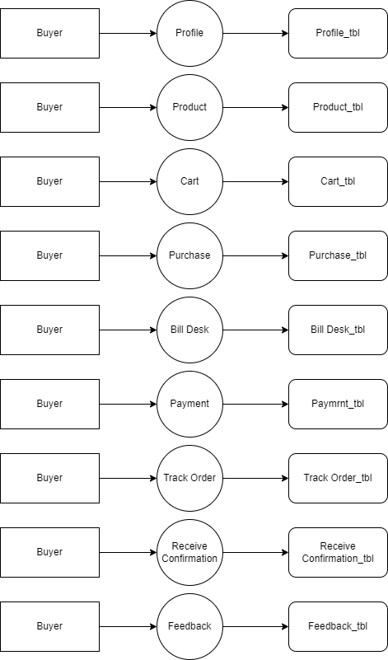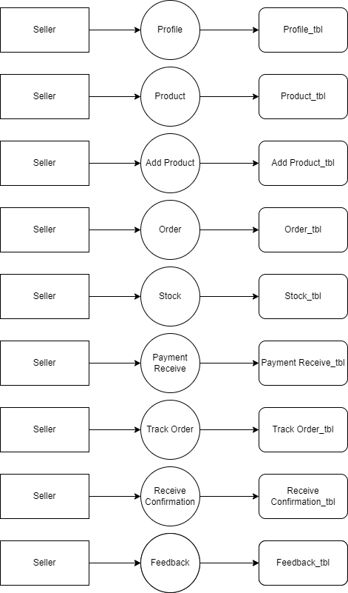

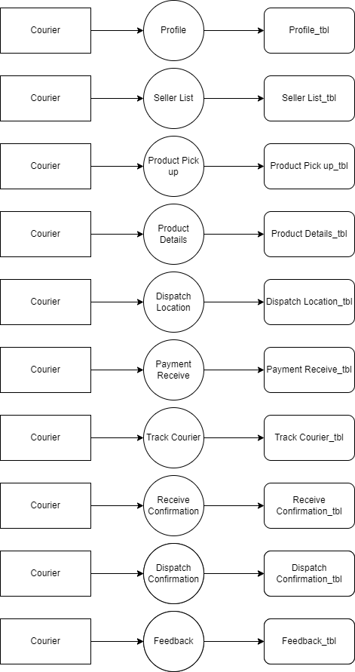

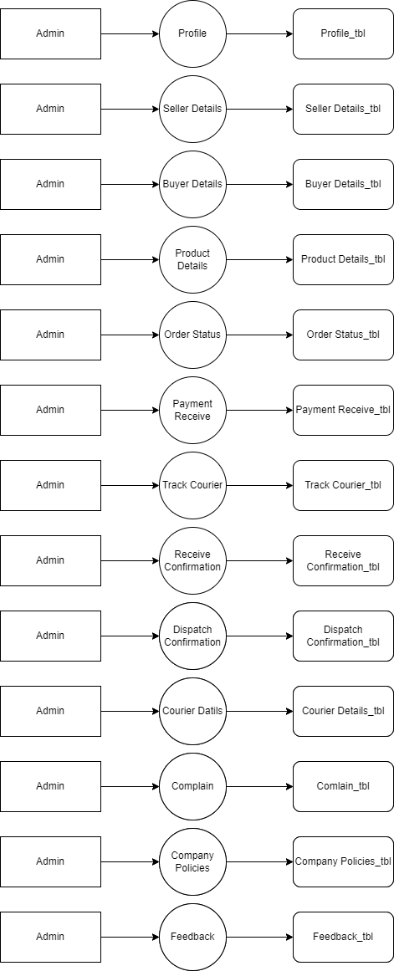

**Q5. What is Flow chart? Create a flowchart to make addition of two numbers.**

A flowchart is a diagram that depicts a process, system or computer algorithm. They are widely used in multiple fields to document, study, plan, improve and communicate often complex processes in clear, easy-to-understand diagrams.

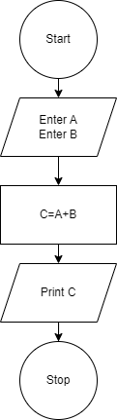

**Q6. What is Use case Diagram? Create a use-case on bill payment on paytm.**

In the Unified Modeling Language (UML), a use case diagram can summarize the details of your system's users (also known as actors) and their interactions with the system. To build one, you'll use a set of specialized symbols and connectors. An effective use case diagram can help discuss and represent:

* Scenarios in which your system or application interacts with people, organizations, or external systems
* Goals that your system or application helps those entities (known as actors) achieve
* The scope of your system

